2024 Curtin Artist-in-Residence Program – Artist’s EoI/Profile
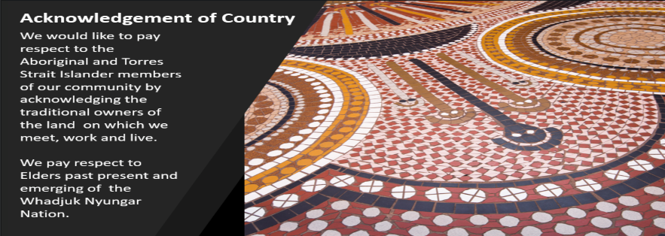
https://staffportal.curtin.edu.au/employment/our-culture/reconciliation/acknowledgment-of-country/
Artist’s Name:
Address:
Phone numbers:
Curtin Email:
Personal Email:
Facebook Artist Link:
Instagram Link:
Website Link:
Brief (one paragraph) biography – creative practice (last 5-10 years)

Undergraduate/Postgraduate Course - Qualifications and University

Industry Experience/previous employment related to The Arts

Previous employment of relevance to the AiR placement

Major studio discipline/production/performance strength area … describe your expertise/major skillset.

Preference for AiR placement … e.g., geographic location/suburb; sector (government/non-government) primary or early childhood etc.

Please select a couple of schools in which you are interested from our 2024 list on the Creative Education Research Hub Webpage.

Other information of relevance to the placement, e.g., transport limitations, time constraints (childcare etc.)

Previous work as an Artist-in-residence (location and details of the project).

Any other information related to the residency program.

2024 Artist-in-Residence Program

Artist’s Expression of Interest and Undertaking.

Name ____________________________________________
Curtin Degree Program _______________________________Course Year _____________

I wish to be considered for inclusion in the 2024 Curtin-ECU Artist in Residence (AiR) program and agree to abide by the program protocols.
I agree to act professionally and in accordance with my University's Code of Conduct and the school visitors’ policy at all times.
I understand that I must provide a copy of my Working-With-Children Clearance to the School Host and AiR program coordinator before commencing any work in schools and that the project I undertake must comply with the approved proposal.

Signed ____________________________________________

Date _____________________________________________

