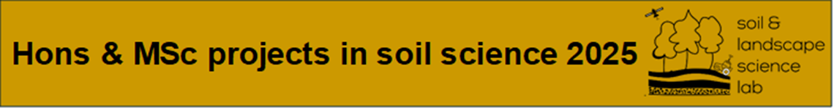

**Project 1. Developing techniques for measuring soil microbial carbon**

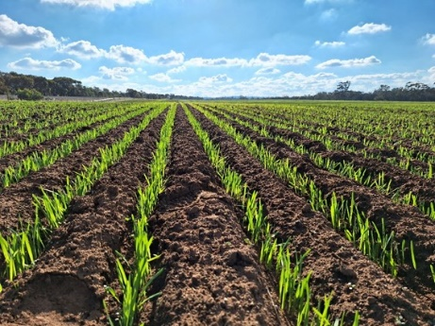Supervisors: Dr Andrea Bravo-Escobar, Prof Raphael Viscarra Rossel

Email: [andrea.bravo-escobar@curtin.edu](mailto:andrea.bravo-escobar@curtin.edu)

Soil microbial biomass carbon (MBC) quantifies the amount of carbon that is part of the living microbial biomass. This living component of soil serves as a crucial ecological indicator, playing a vital role in the decomposition and mineralization of plant and animal residues. However, the methods for measuring and interpreting MBC are not universally applicable and should be adapted to the specific context of climate, land use, management practices, and research objectives. This highlights the need to develop a standardized methodology, particularly for some of the sandy and low carbon soils of Western Australia. In this project you will learn about soil carbon cycling, soil microbial biomass and some laboratory methods essential for understanding carbon processes in soils

**Project 2. Characterising soil clay mineralogy with near-infrared spectroscopy**

Supervisors: Prof Raphael Viscarra Rossel

Email: [raphael.viscarra-rossel@curtin.edu.au](mailto:raphael.viscarra-rossel@curtin.edu.au)

Soil is a complex matrix of varying organic and mineral components with different particle sizes and water. Soil visible–near infrared spectra hold information on the fundamental composition and can be used to characterise soil properties, including clay mineralogy. This project aims to measure the iron oxide and clay mineralogy of the soil samples from the Muresk Institute farm using visible–near infrared spectra. In this project, you will learn about soil mineralogy and spectroscopy. You will also develop skills in the measurement of soils with spectrometers and spectroscopic data analysis with R.

**Project 3. Carbon allocation in the roots of WA native plants**

Supervisors: Dr Andrea Bravo-Escobar, Prof Raphael Viscarra Rossel

Email: [andrea.bravo-escobar@curtin.edu](mailto:andrea.bravo-escobar@curtin.edu)

Plant roots play a crucial role in the nutrient and carbon cycling in terrestrial ecosystems, yet many aspects of their processes and interactions within the soil remain poorly understood. This project offers the opportunity to investigate how roots from WA native species contribute to soil carbon allocation, sequestration and stabilisation. This project aims to provide insights into carbon root-soil processes for understanding carbon storage in soils from WA natural ecosystems. You will learn about soil carbon cycling, using some soil molecular techniques and other laboratory methods essential for understanding carbon processes in soils.

**Project 4. Impact of wildfire on soil carbon in the Northern Jarrah Forest**

Supervisors: Dr Lewis Walden, Dr Andrea Bravo Escobar

Email: [lewis.walden@curtin.edu.au](mailto:lewis.walden@curtin.edu.au)

Fire is an integral component of Australian ecosystems. Climate change is increasing the frequency of wildfires, which significantly impact on forest ecosystems, yet the effects on soil carbon remain unclear, particularly in forests that resprout. This project will investigate how a severe wildfire alters soil carbon stocks and organic matter in the Northern Jarrah Forest. Students will gain hands-on experience in soil carbon analysis using modern laboratory methods, fire ecology, data analysis and statistical methods.

**Project 5. Spectroscopic characterisation of blue carbon soils**

Supervisors: Dr Lewis Walden, Prof Raphael Viscarra Rossel

Email: [lewis.walden@curtin.edu.au](mailto:lewis.walden@curtin.edu.au)

Blue carbon ecosystems (BCE), including tidal marshes, mangroves, and seagrasses, are threatened ecosystems that provide critical socio-ecological services and economic resources. To improve our understanding of soils in BCEs and the processes which have contributed to their formation, we need

to quantify their properties accurately. This project aims to characterise the

physical and chemical soil properties of BCEs using modern analytical tools, including visible and infrared spectrometers. This project represents an excellent opportunity to learn about blue carbon soils and soil spectroscopy. Skills development will include the development of protocols for measuring soils with different spectrometers and data analysis using multivariate statistics and machine learning methods.

**Project 6. Measuring soil colour as a proxy for soil carbon**

Supervisors: Prof Raphael Viscarra Rossel

Email: [raphael.viscarra-rossel@curtin.edu.au](mailto:raphael.viscarra-rossel@curtin.edu.au)

Colour is used to identify soils. It is an indicator of soil properties and processes. Soil colour depends primarily on iron oxide minerals and organic matter. Darker soil has a finer texture and more organic matter, while lighter soil has a coarser texture and less organic matter. Colour can also indicate soil redox condition; brownish-red soil is well aerated and has better drainage than greyish soil. This project aims to measure the colour of diverse topsoil samples and develop relationships between different soil colour models and carbon content. In this project, you will learn about the significance of colour for understanding soil and the application of colour space models (RGB, HVC, CIE, etc.) in soil science. You will learn to use sensors, cameras and spectrometers for measuring soil, laboratory analysis of soil carbon, and data analysis with the R software.

**Project 7. Estimating plant biomass with hyperspectral imagery and multispectral imagery**

Supervisors: Dr Mingxi Zhang, Prof Raphael Viscarra Rossel

Email: [mingxi.zhang@curtin.edu.au](mailto:mingxi.zhang@curtin.edu.au)

Accurate estimation of plant biomass is crucial for activities such as agriculture management and crop yield prediction and carbon accounting; however, the conventional methods that involve labour-intensive sampling and experiment are time-consuming and inefficient for large-scale mapping. Remote sensing approaches, which utilize images captured from satellites or aircraft, offer a promising alternative, particularly using hyperspectral and multispectral imaging. The project represents an excellent opportunity to learn and develop digital soil science skills, including soil sampling design, soil sampling and carbon analyses with remote sensing, spatial data analysis and machine learning methods.

**For more information on the Soil & Landscape Lab visit:**

[**curtin.edu/soil-landscape-sci**](https://aus01.safelinks.protection.outlook.com/?url=http%3A%2F%2Fcurtin.edu%2Fsoil-landscape-sci&data=05%7C02%7Clewis.walden%40curtin.edu.au%7C44e7ebed963c44bf887e08dcd137f6f8%7C5a740cd757684d09ae13f706b09fa22c%7C0%7C0%7C638615285510362160%7CUnknown%7CTWFpbGZsb3d8eyJWIjoiMC4wLjAwMDAiLCJQIjoiV2luMzIiLCJBTiI6Ik1haWwiLCJXVCI6Mn0%3D%7C0%7C%7C%7C&sdata=frH2fpp0fpoHQOH5Sxe3fPTBllYWb6jDRmDpdtzSarU%3D&reserved=0)